# Manual Test Plan

## 

1. link: <http://localhost:3000/> should be like

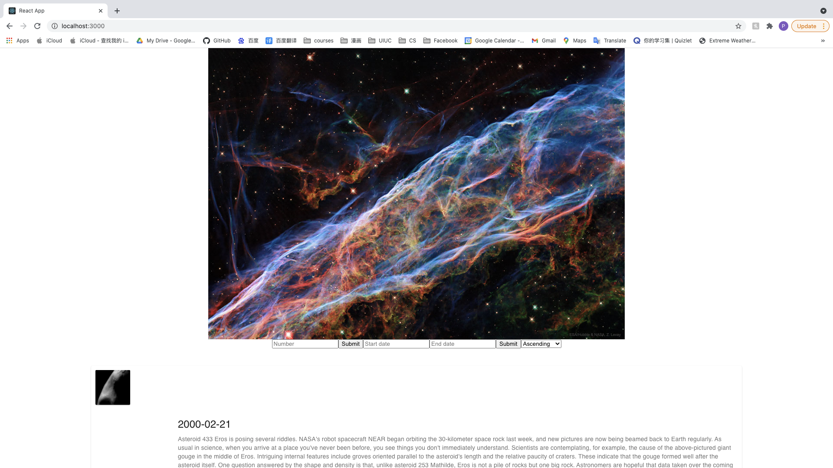

With the today’s image from APOD api always displays at top of the page

1. Some images with corresponding information should be displayed at the bottom as a list

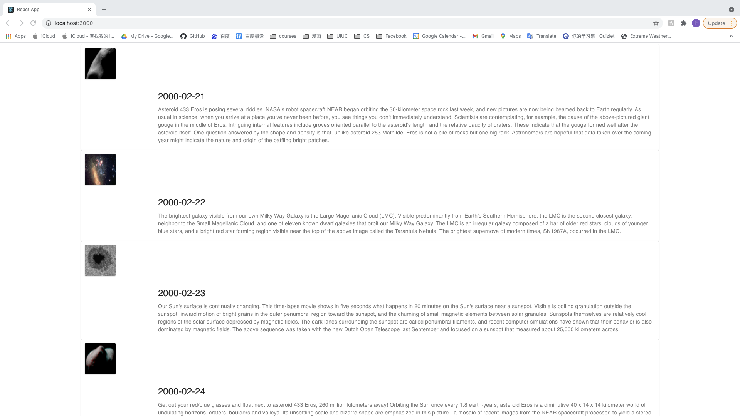

1. By clicking any images display at the bottom, it will display a bigger image, with image information provided below

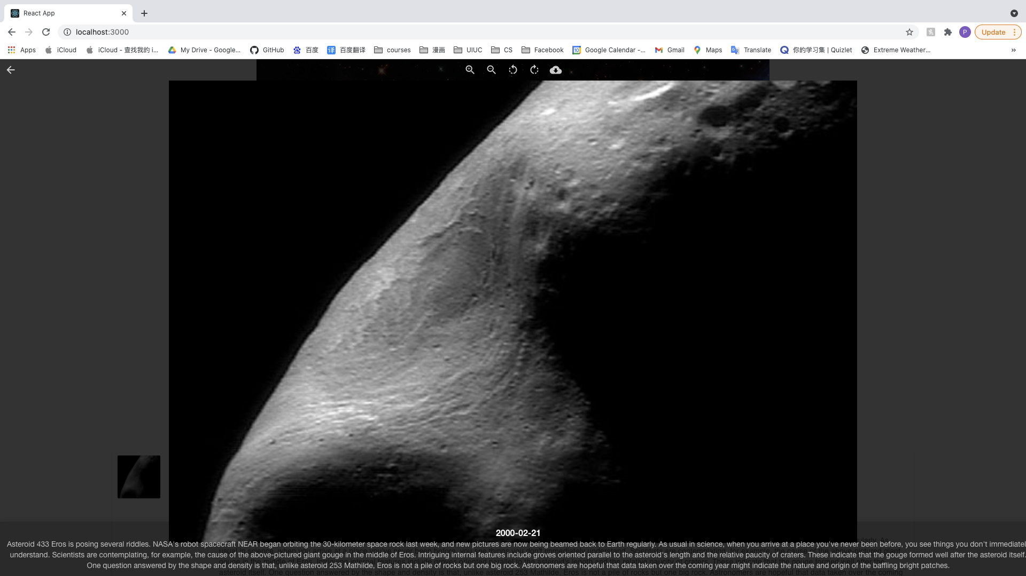

1. Clicking left top arrow, you should go back to the main page



1. The part between today’s image and image list should be some form that can be used to change the image list displaying as below



1. Input 2 to the first form, should randomly display 2 images in the image list



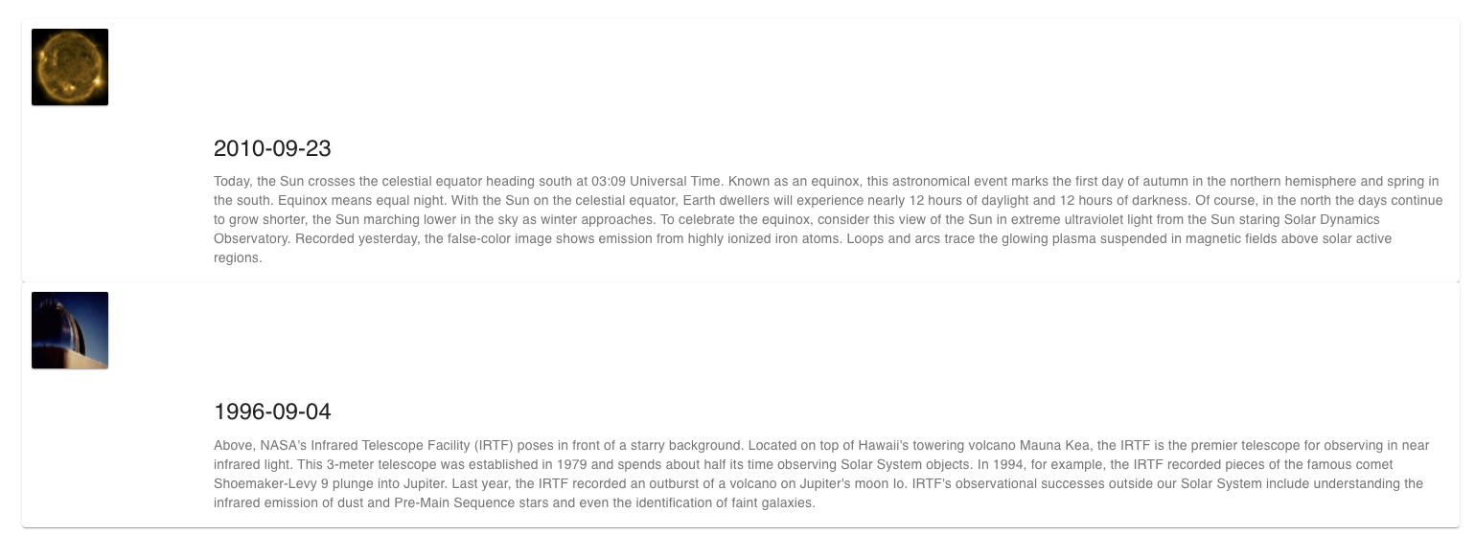

1. After clicking the submit button, the number you input should be cleared

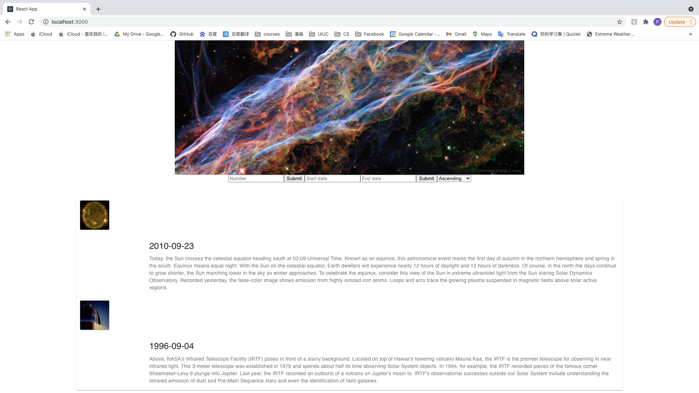

1. If you input anything rather than integer, it will show some error messages

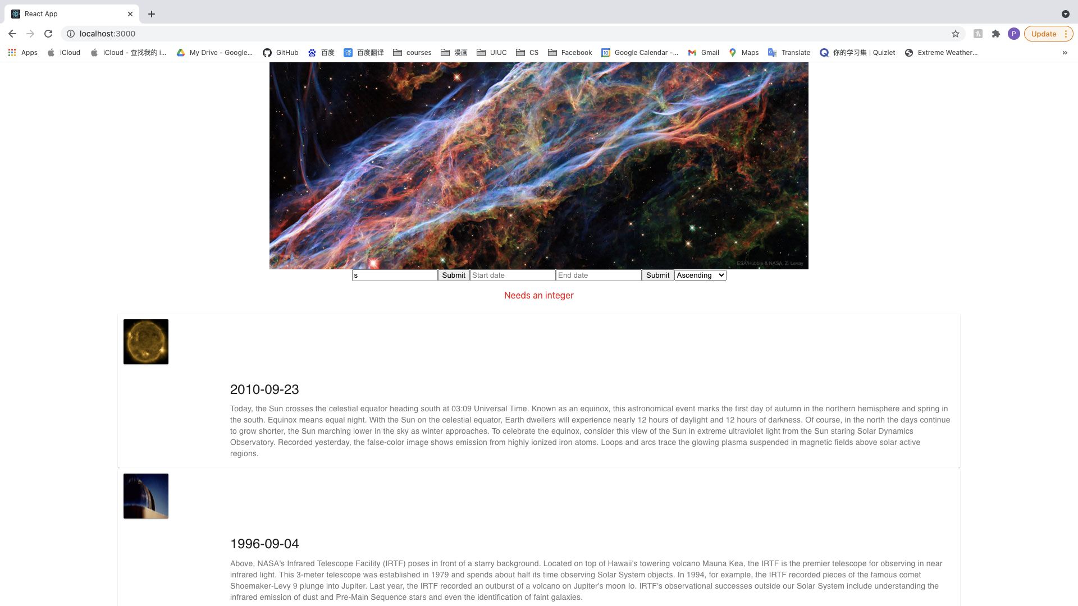

1. The input won’t be cleared with the error message shown up
2. Inputting any integer like 3 will clear the error message and randomly show another 3 images below

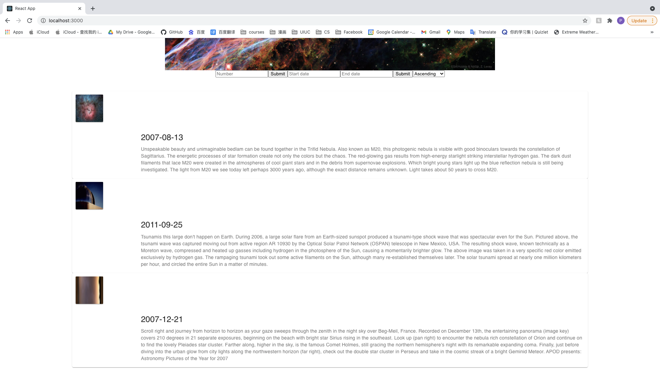

1. Choosing Descending in the left selection, will reorder image list with descending order corresponds to it’s date



1. Choosing Ascending in the left selection, will reorder image list with ascending order corresponds to it’s date

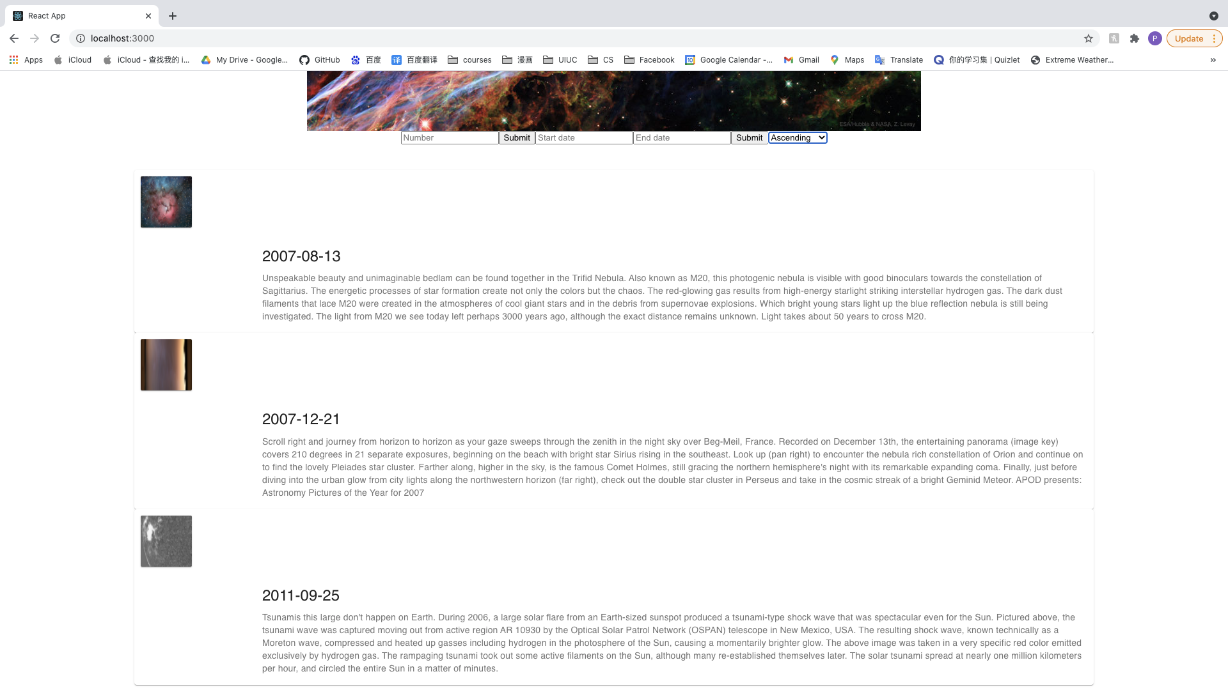

1. With start date input as 2020-01-03, and end date input as 2020-01-06

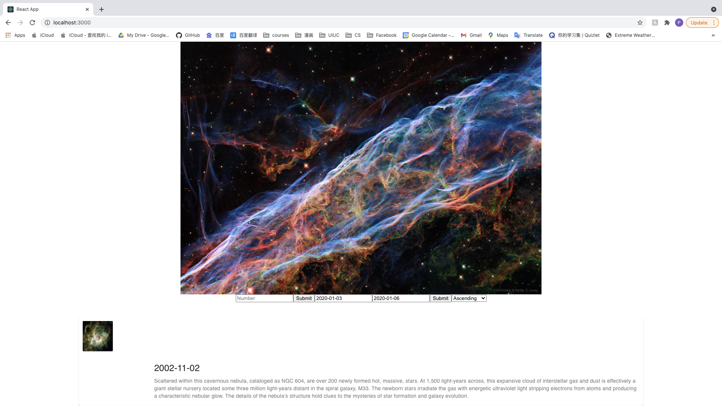

It should display the corresponding images and information as below

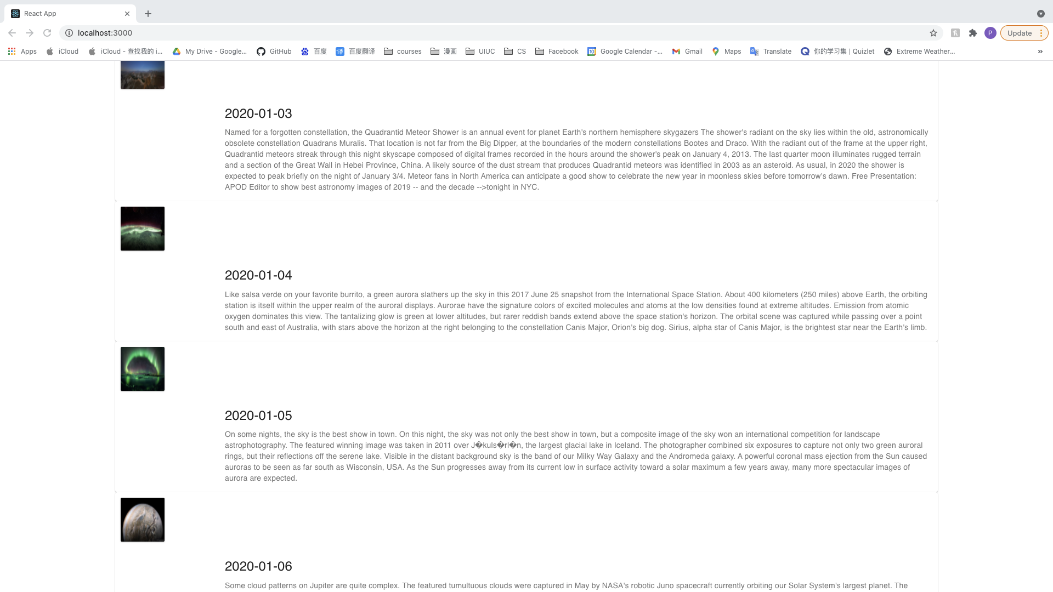

1. With invalid input like an string, it should display error message as “Needs in form yyyy-mm-dd”

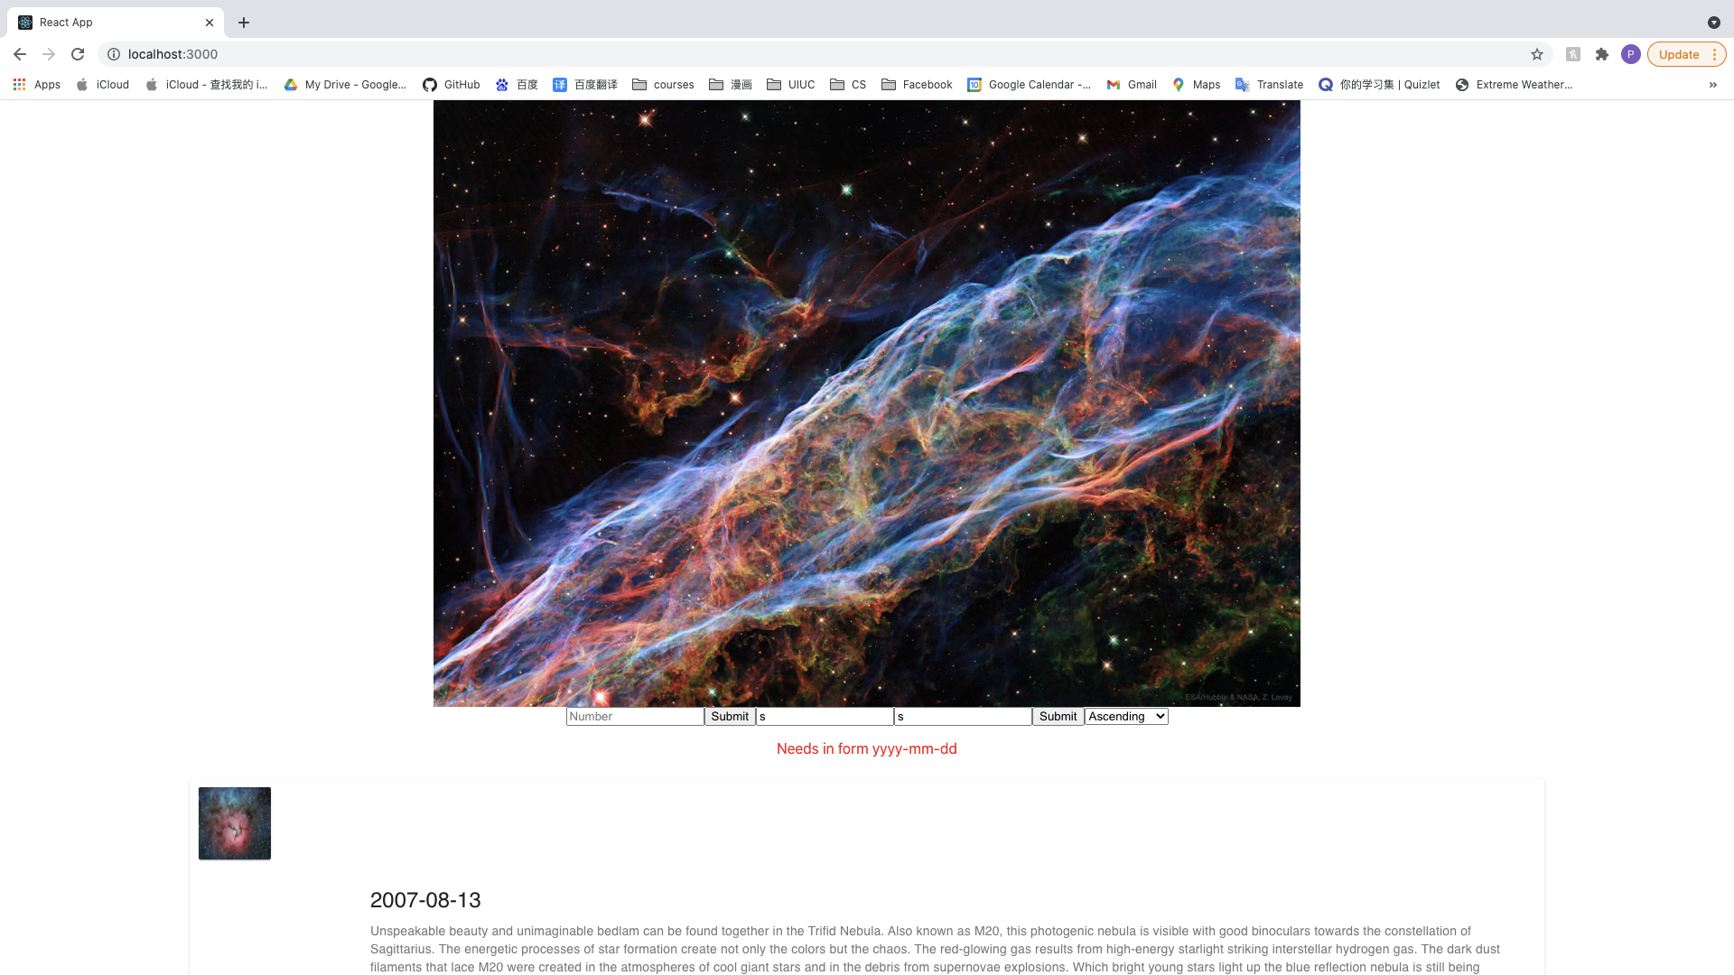

1. With invalid input like start date with 2020-1-3, and end date input with 2020-1-6, should display “Needs in form yyyy-mm-dd”

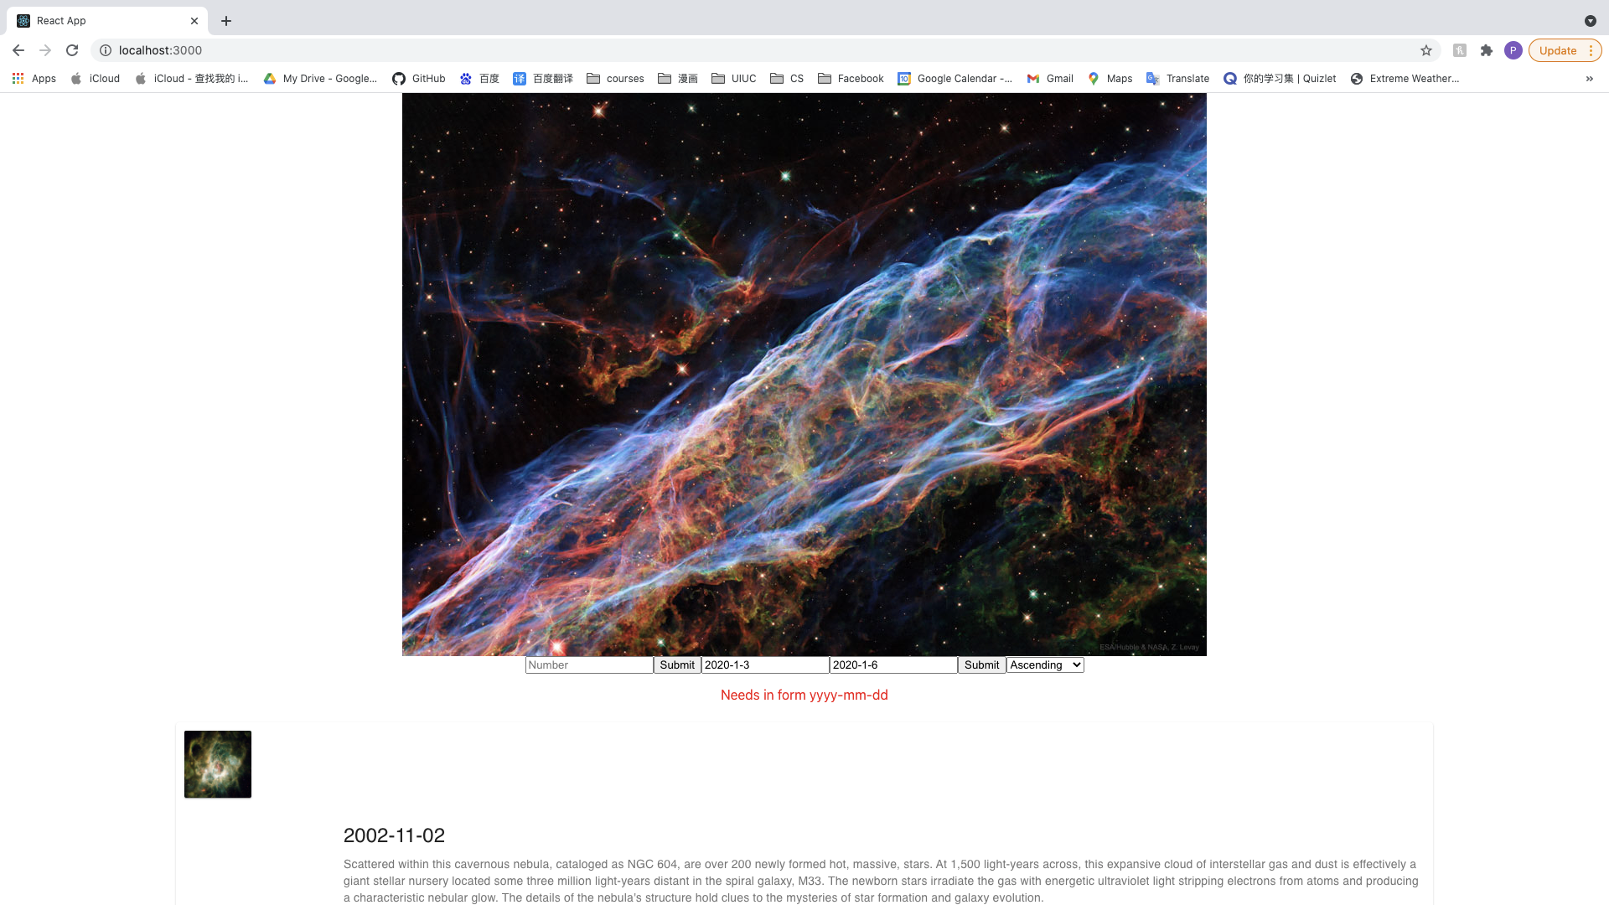

1. With invalid input like input like yyyy-mm-dd, and end date input like yyyy-mm-dd

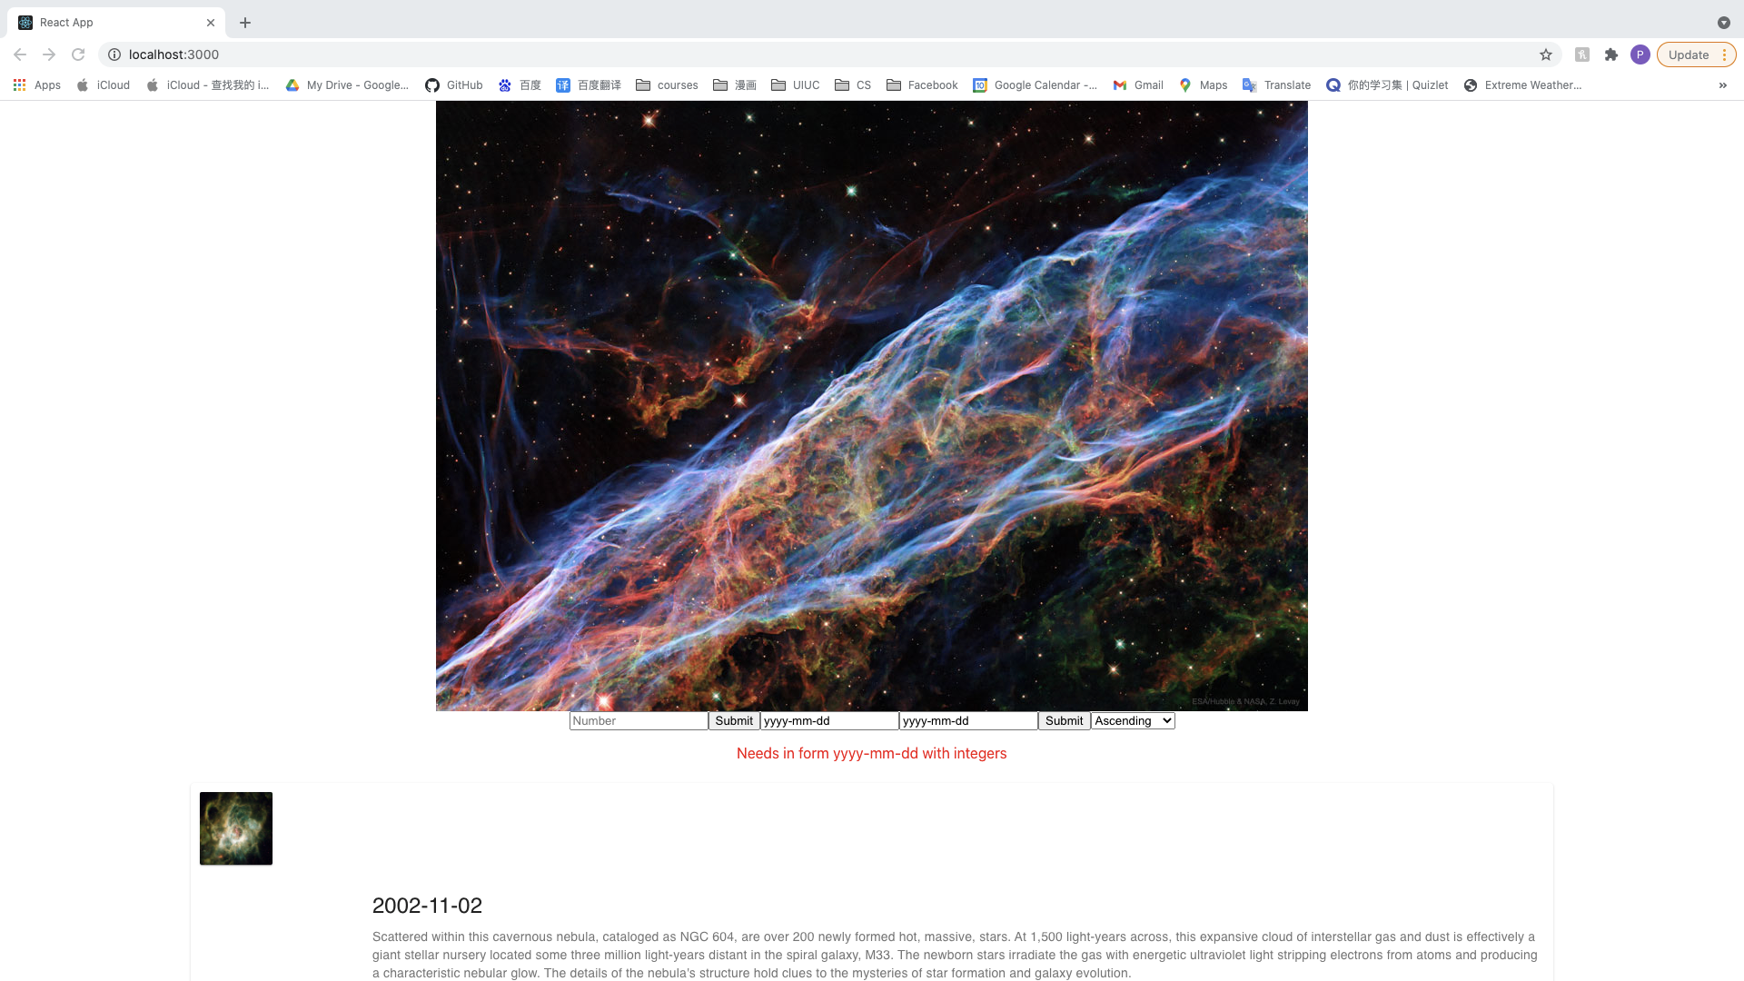

1. With invalid input like input like 2020-03-08, and end date input like 2020-01-01, should display “Start date should before end date”

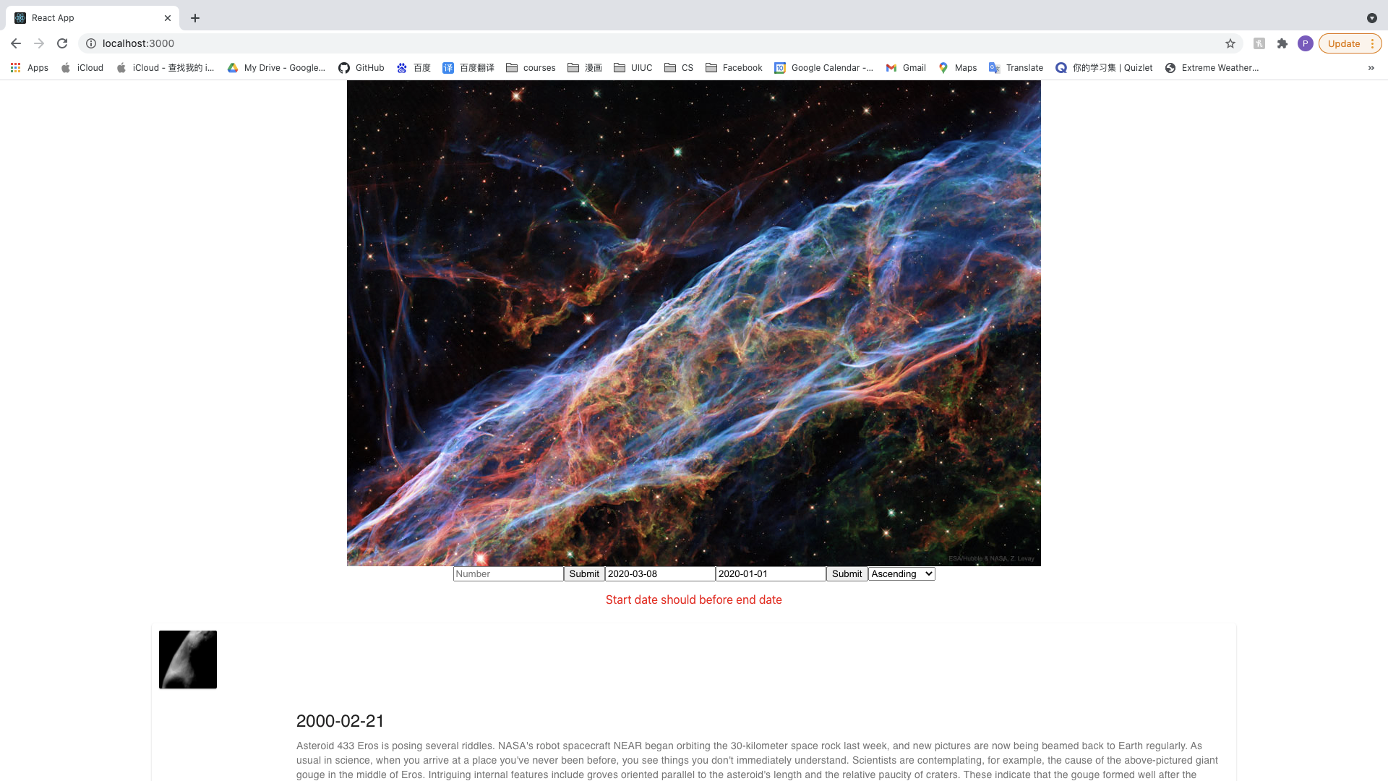

1. With invalid input like input like 2020-03-08, and end date input like 2023-01-01, should display “Needs a valid date input”

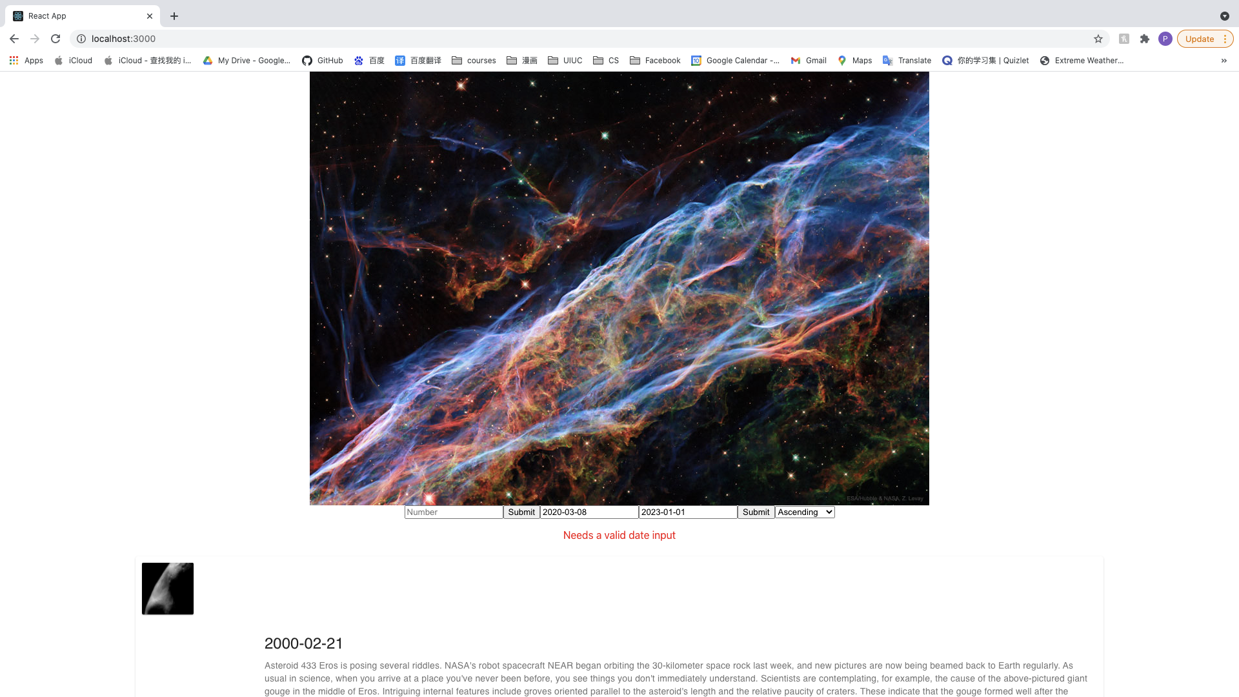

1. With invalid input in date form, any input value won’t be cleared after clicking submit
2. With valid input in date form, any input value will be cleared after clicking submit